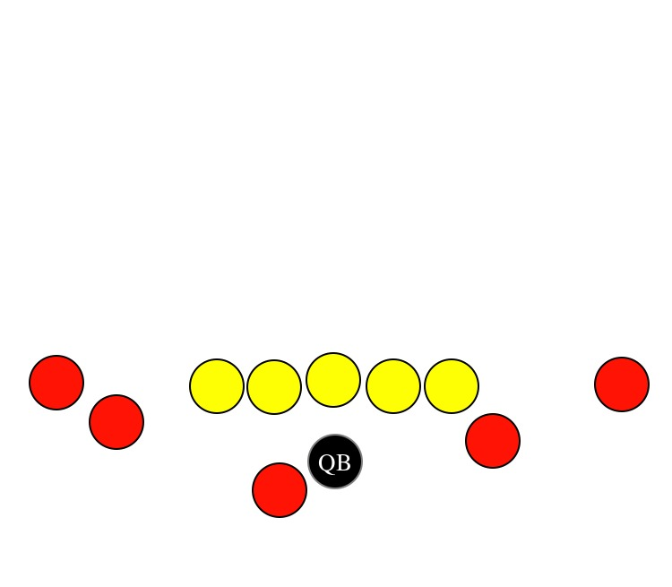

**PRO RIGHT- BASE FORMATION**

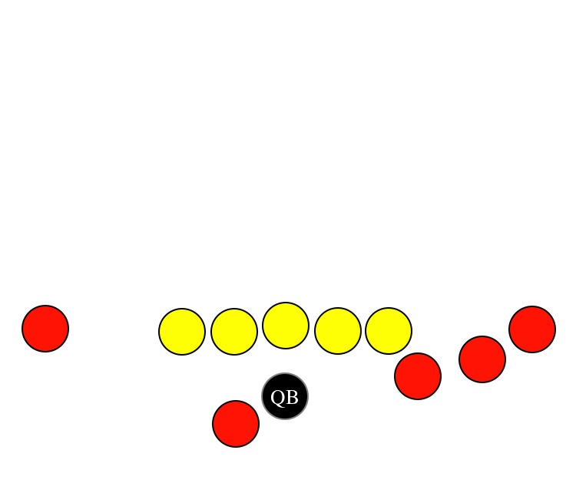

**TRIO RIGHT**

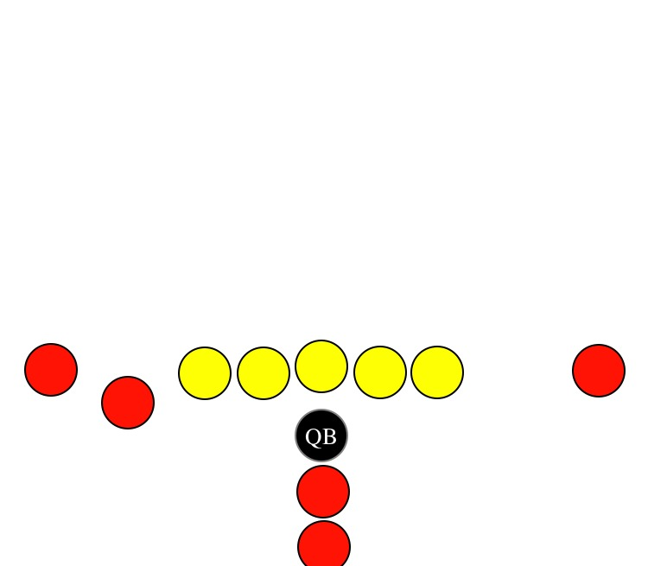

**I-FORMATION**

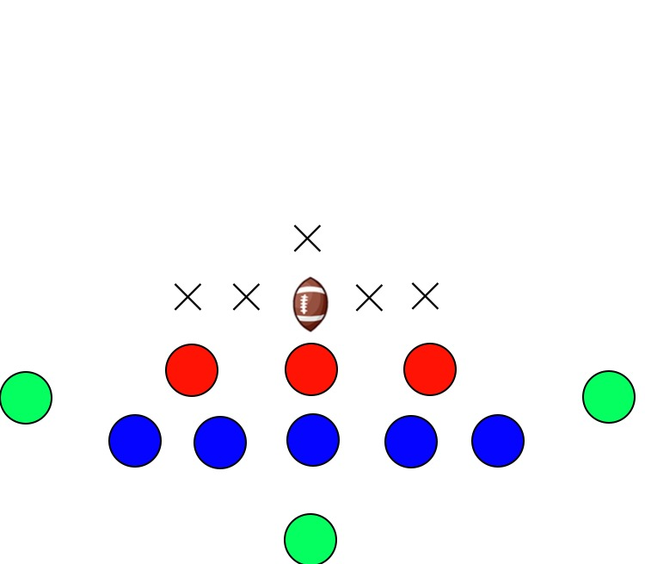

**DEFENSE**

**BASE 3/5**

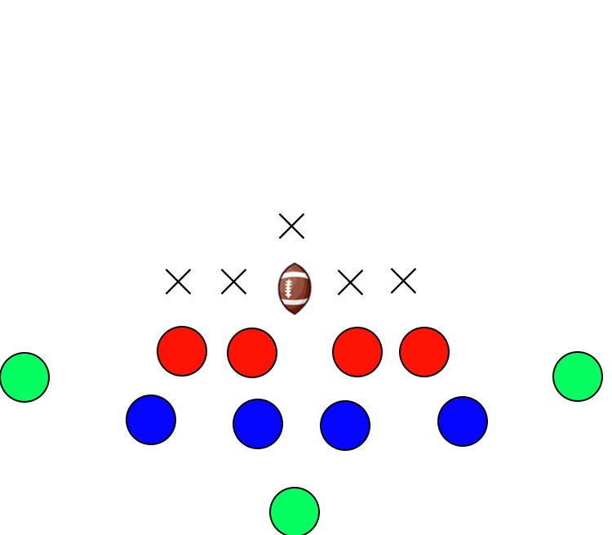

**DEFENSE**

**4/4**